A Project Report on Analysis of Supermakert Store Dataset
- Cleaning the dataset:
Remove Blank Spaces:
Home → Find & Select → Go To Special → Blanks
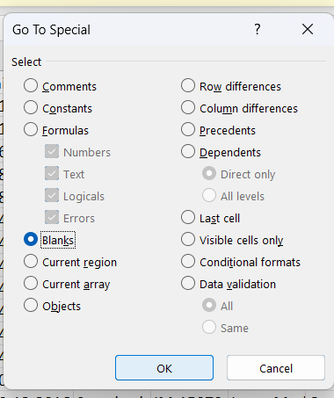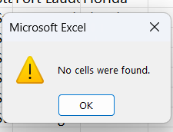
Remove Extra Spaces:
Use TRIM.
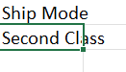
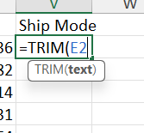

Remove Duplicates:
Select dataset.
Go to: Data → Remove Duplicates
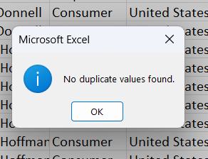
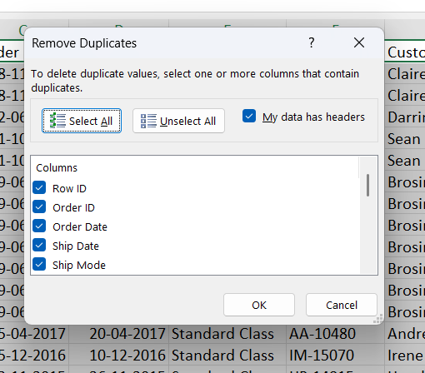

FORMAT DATES PROPERLY:
Home → Number → Short Date
- Preparing Master Dataset
The Goal is to combine all the useful information into one data sheet.
This phase includes:
-XLOOKUP
-Relational thinking
i – Add Return Status Column
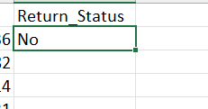
ii – Add Regional Manager Column
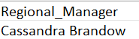
iii – Create helper Columns
- Profit category:
To analyse high profitable products :
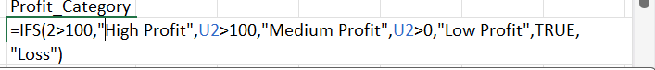
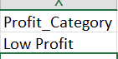
- Discount Category:
To analyse effects of discount on sales and profit
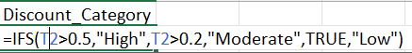
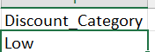
- Order Month:
To analyse monthly orders:
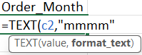
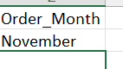
- Shipping Days:
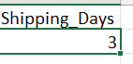
- Pivot table Analysis:
Q-1: Which region generates highest sales?
Pivot Table -1 – Region Wise sales:
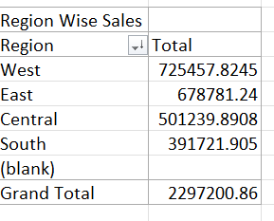
West has the highest Sales.
Q-2 : Which category is most profitable?
Pivot Table -2 – Category wise Profit
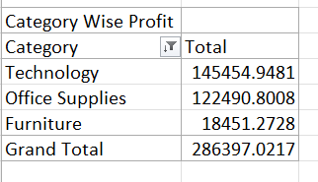
Technology is the most Profitable Category.
Q-3 : Which customer segment contributes highest sales?
Pivot Table -3 – Customer segment wise Profit
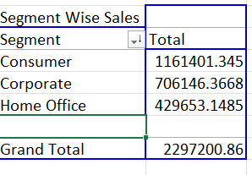
Consumer Segment provide highest sales.

Q-4 : Which months generate peak sales?
Pivot Table -4 – Month Wise Sales
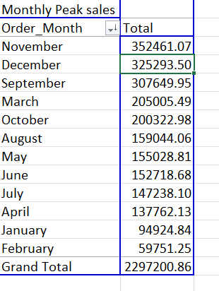
November generates highest sales.
Q-5 : Do high discounts reduce profits?
Pivot Table -5 – Discount Wise Profit
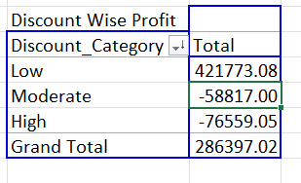
Yes Higher Discounts Leads to low profit.

Q-6 : How many orders were returned?
Pivot Table – 6 – No of Products Returned
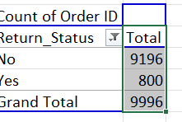
800 Products were returned.

Q-7 : Which manager handles highest sales?
Pivot Table – 7 – Manager Performance
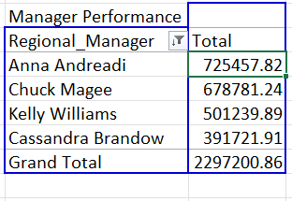
Anna Anderadi who manages West region generates highest Sales.

- Pivot Charts:
- Region wise Sales Chart:
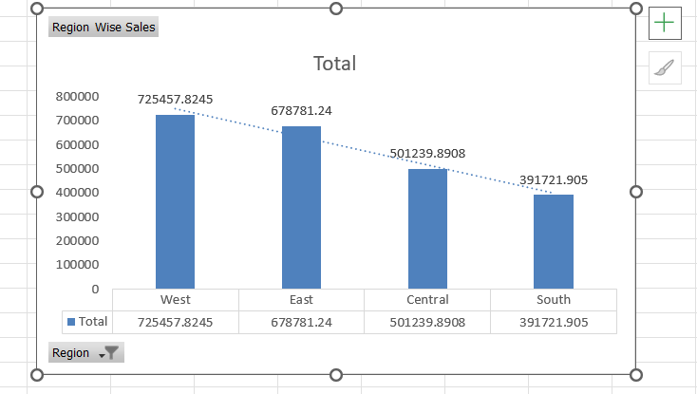
- Category wise Profit
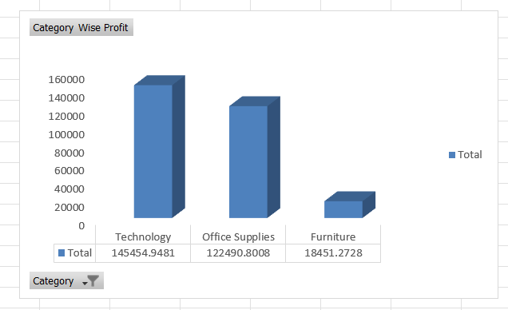

- Segment wise Sales
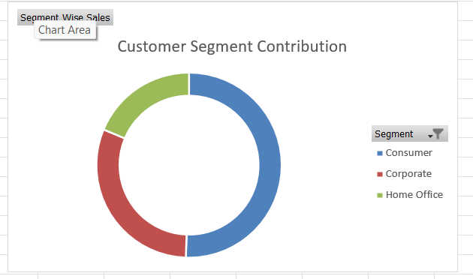
- Monthly Sales Trend
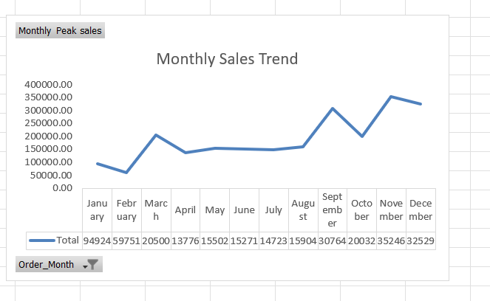

- Discount Impact
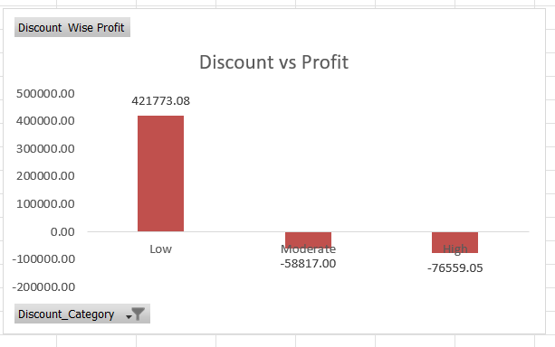

- Returns Analysis
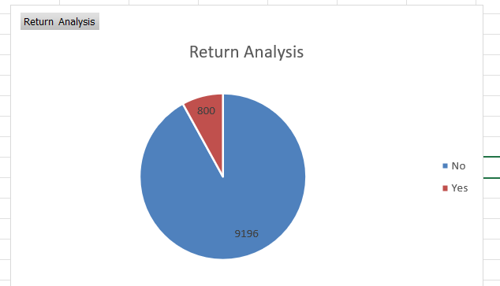

- Manager Performance
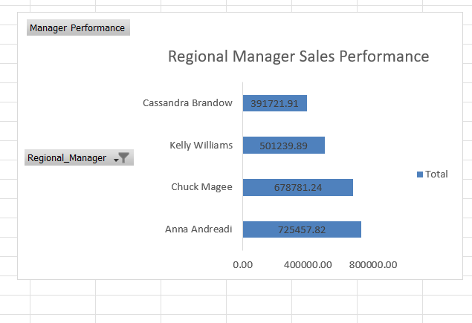

- KPI DASHBOARD:
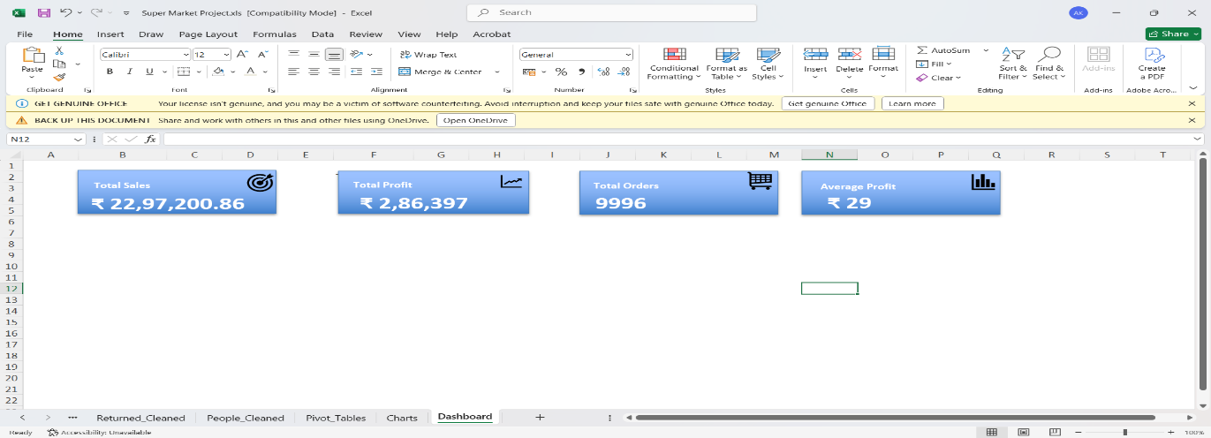

- Interactive Dashboard Using Filters and Slicers with KPIs:
I have use three Slicers such Segment, Region and Category to make my dashboard Interactive. The results are as follows:
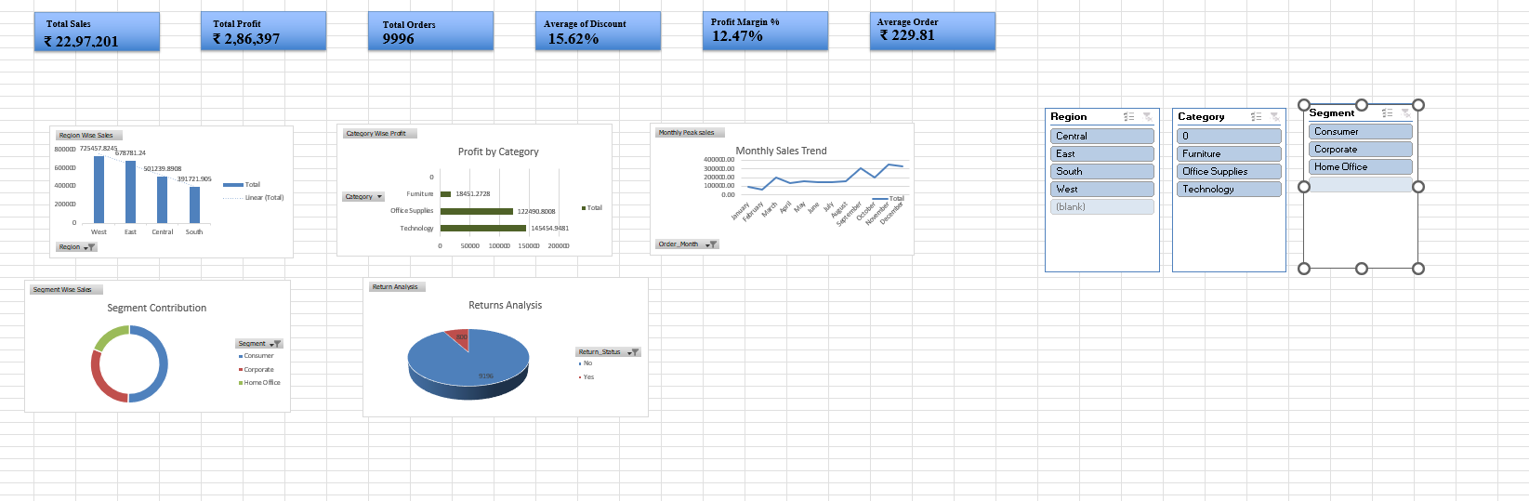
Initially before any filter:
After applying different filters:
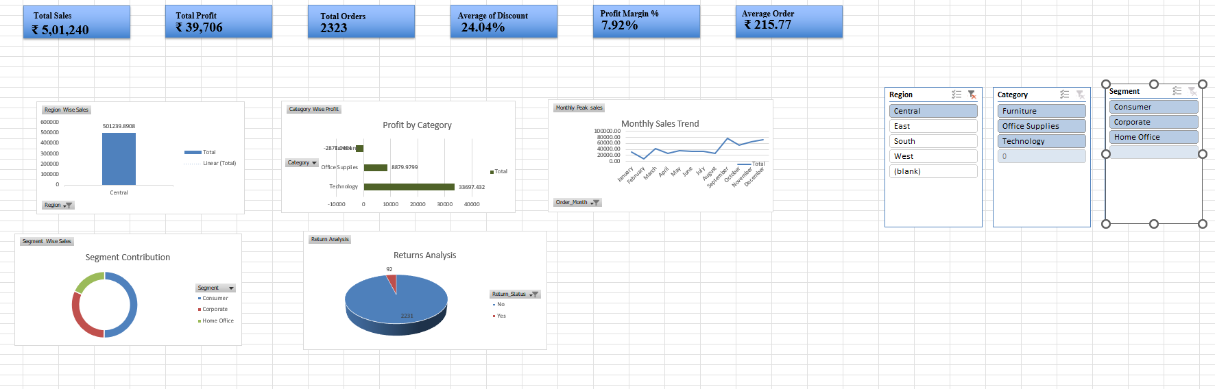
- Selecting different regions :

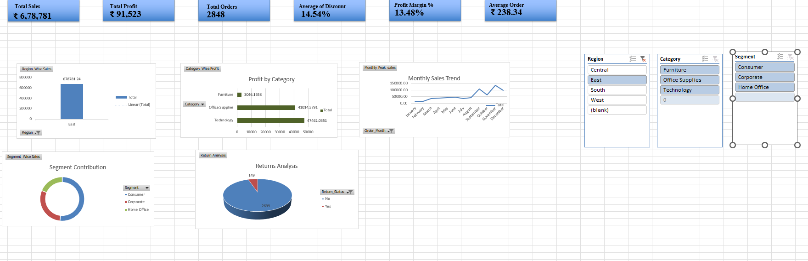

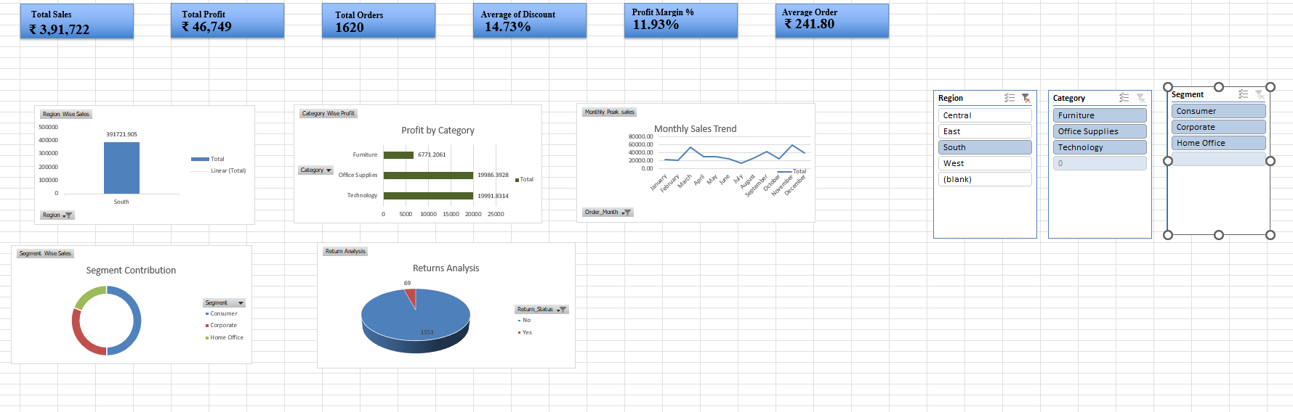

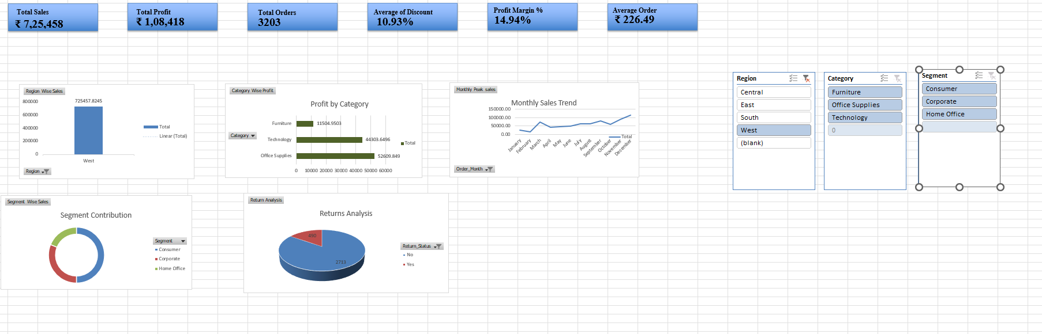

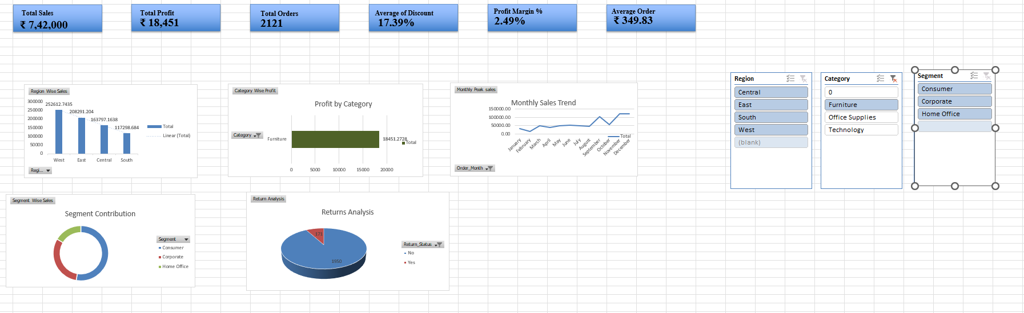
- Selecting different Category:

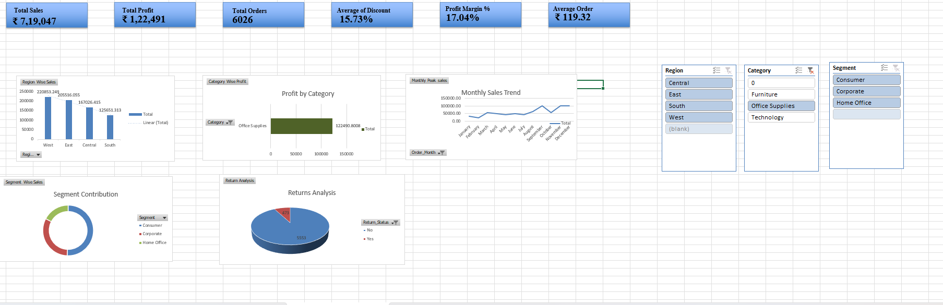

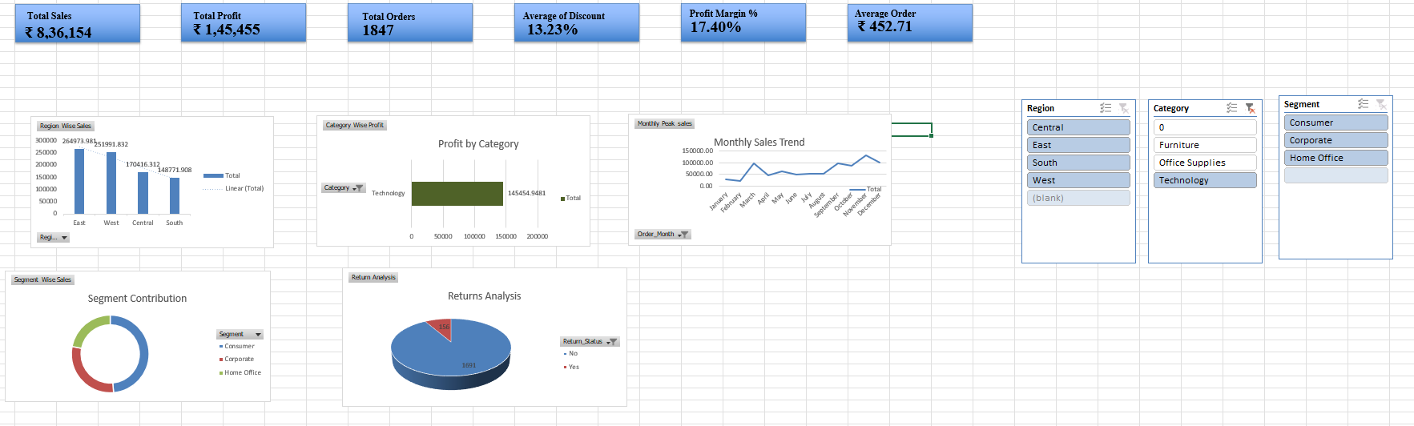

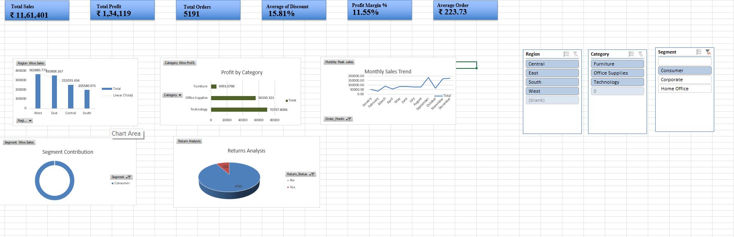
- Selecting Different Department:

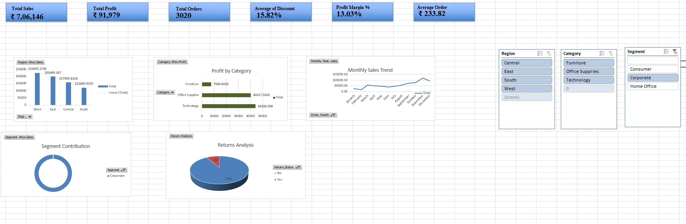

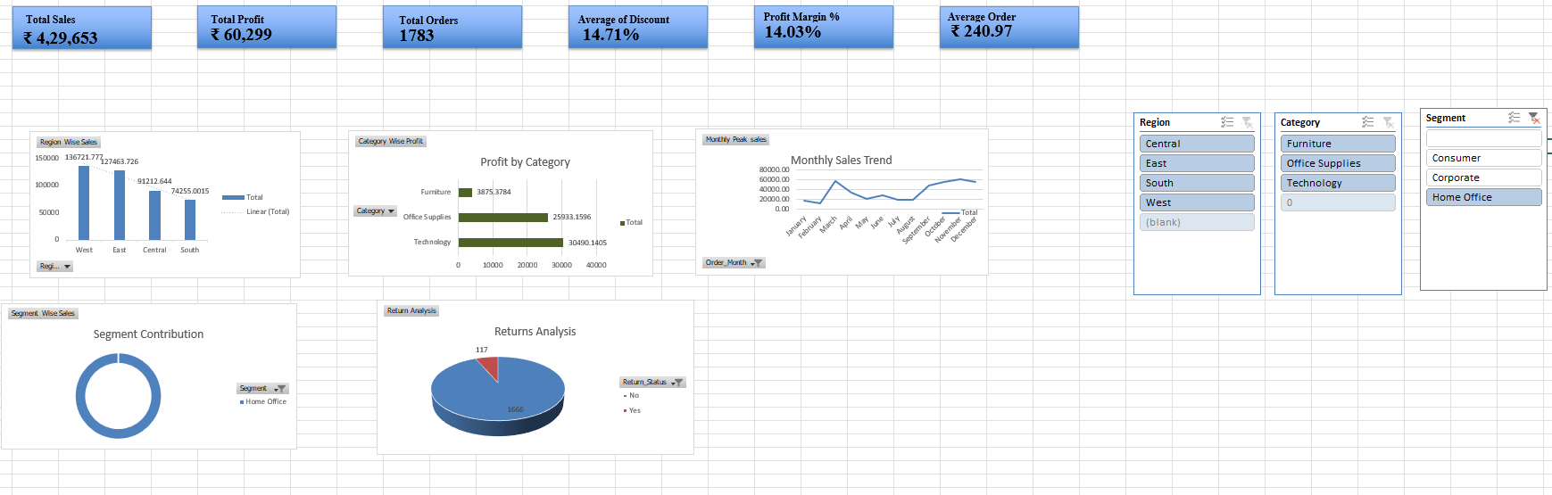

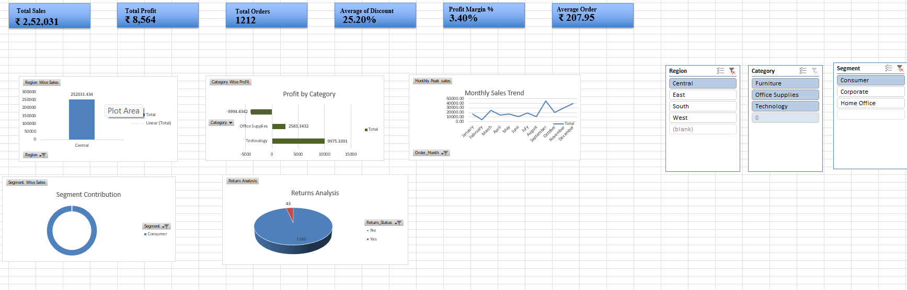
- Selecting Region and Segment:

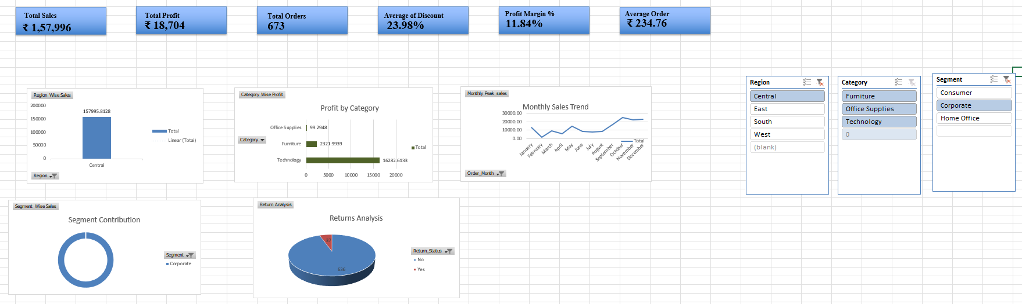

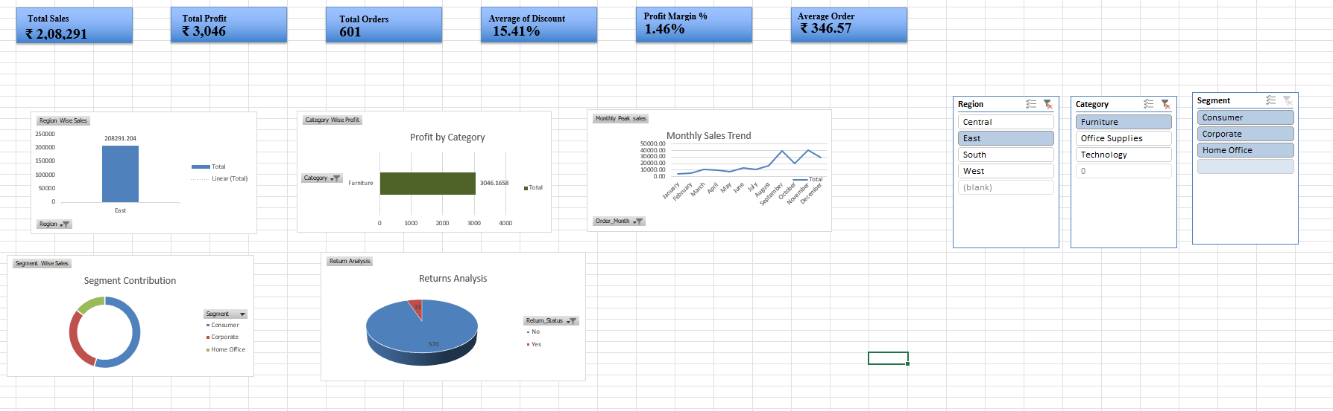
- Selecting Region and category:

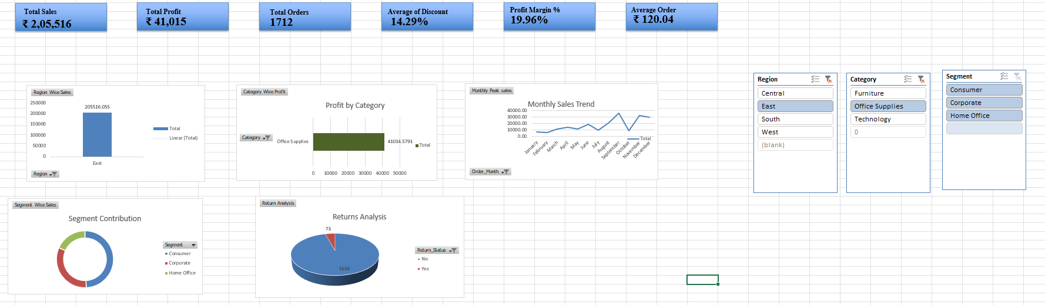

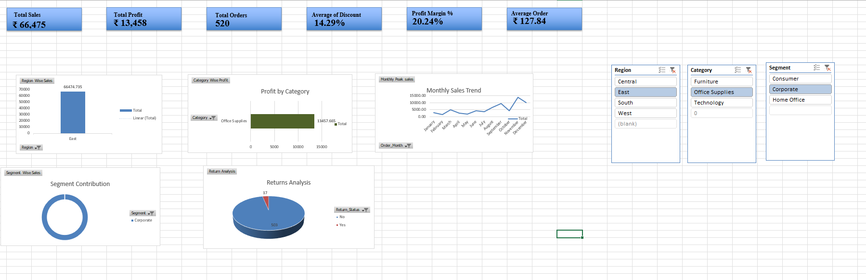
- Selecting all three at once:

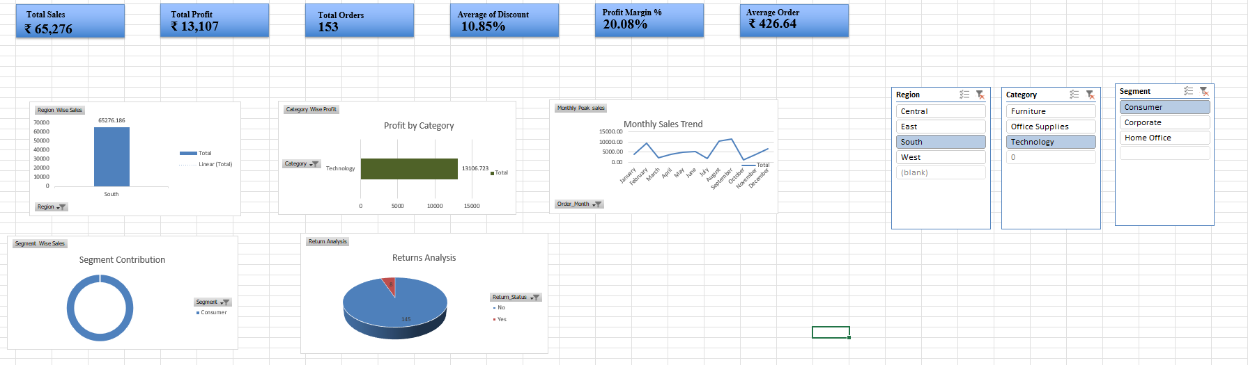

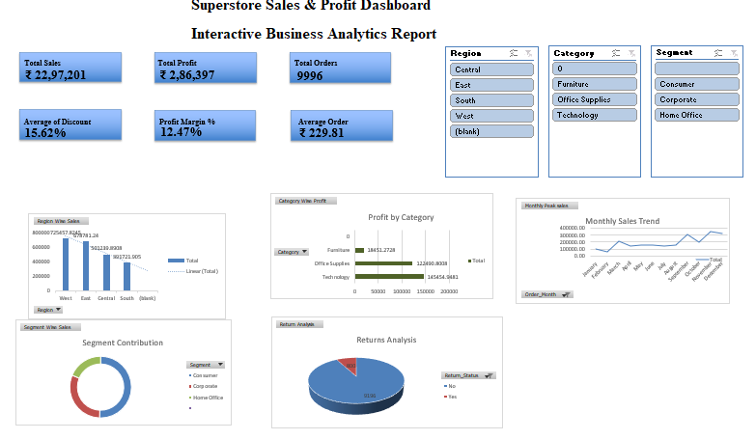
- Final Dashboard:

- Key Insights:

- The West region generated the highest overall sales contribution across all regions.
- Technology emerged as the most profitable product category in the business.
- Consumer segment accounted for the largest share of total revenue and order volume.
- Higher discount percentages showed a negative impact on overall profit margins.
- Monthly sales trends revealed noticeable seasonal fluctuations in customer demand.
- Average profit per order remained stable despite variations in sales performance.
- Return rates stayed within manageable levels, indicating relatively stable operational efficiency.
- Interactive slicer analysis highlighted significant performance differences across regions and product categories.

